THE LOD SCORE METHOD
We have seen how to measure linkage in large segregating populations using Chi square tests and maximum likelihood methods. How does one measure linkage in the type of pedigrees that are produced from human data? Chi square tests are not appropriate.
This type of data is tested by the LOD score method.
To determine whether two genes / markers are linked:
1) First, we examine a number of families that are informative for the loci in question.
For each family, determine the genotype of each parent and of each of the offspring.
Then, try to deduce whether each child has the parental arrangement of alleles or is a recombinant. This is difficult unless the phase of the alleles at the two loci is known.
To determine phase, there must be one (best) or two (not quite so good) parents who is (are) doubly heterozygous for the two loci.
Consider a large family segregating for a rare autosomal dominant trait of high penetrance caused by mutation in a gene on chromosome 4. Each individual with the disease has inherited a mutant copy of the disease gene, D, while every unaffected subject has inherited the normal copies of the disease gene, "+".
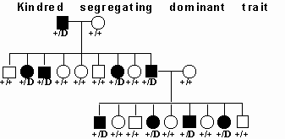
If you compare the inheritance of an unlinked marker, say on chromosome 7, to the inheritance of the disease, you would expect to find independent segregation of the disease and the marker; that is, an affected member of the pedigree would transmit either allele of the chromosome 7 locus to an affected offspring with equal likelihood:
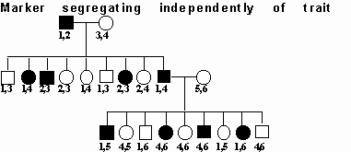
You can see that the affected father in generation 1 has transmitted allele 1 to two affected progeny and allele 2 to two unaffected offspring, not different from the result expected by random segregation of the disease and marker.
Instead, imagine that the polymorphic marker is on chromosome 4, linked to the disease locus at a recombination fraction of zero. In this case, you would expect to find that every affected member of the pedigree has inherited the identical allele of this marker, and that none of the unaffected members of this pedigree have inherited this same allele.
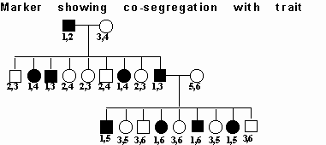
So, every affected member of the pedigree has inherited allele 1 while this allele has not been transmitted to any of the unaffected members. This precise co-segregation allows you to hypothesizethat the marker locus and the disease locus are physically linked on chromosome 4. Thus, with a completely informative marker locus (i.e., no ambiguity as to which marker allele is transmitted to each offspring) and complete information in this large pedigree (i.e., we are not missing critical individuals such as a parent who died from the disease), one does not need careful statistical analysis to deduce that the trait and marker loci are linked. Unfortunately, for human studies, available information is not commonly so complete. Moreover, the situation becomes more complicated as one allows for recombination between the trait and marker loci. So, you need to be able to evaluate the statistical significance of an observed co-segregation of trait and marker.
This is a family that is segregating for two traits, blood type and nail patella syndome, a dominant gene that gives you funny-looking fingernails and has some more serious consequences:
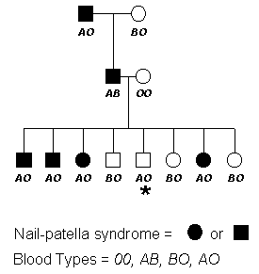
Questions to ask:
What is the inheritance of the two traits?
  - Nail-patella syndrome - (affected individuals indicated by filled symbols) - dominant
  - Blood Type - A and B codominant and each dominant to O
We are taking these inheritance types as given here. Note that from the segregation in this pedigree, you could not determine that Nail Patella was dominant. However, for the trait to be recessive would require that 2 individuals with the trait had married into this family, which would be unusual for a rare trait.
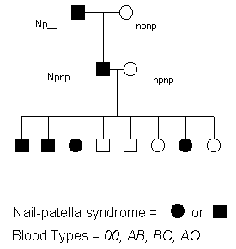
Blood type alleles can be fully determined for each individual because of the co-dominant nature of the genetic system.

What type of cross is this?
- Essentially a test cross - AB Npnp x OO npnp (an individual heterozygous at both loci crossed to an individual homozygous at both loci)

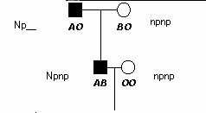
Is this cross informative?
- Yes - the phase of the alleles at the two loci can be determined by examining the genotypes of the grandchildren. Note: information from the grandparents is useful in determining this.
Are there any linkage associations evident?
- Yes - alleles A and Np appear to be linked. Why? Because the 2 alleles are typically present in the same individuals.
Are there any recombinant individuals in the pedigree?
- 1, noted by the asterisk in the figure. Why? She has the A blood type allele but is not affected with Nail Patella.
What is the percent recombination?
- If only the grandchildren in the pedigree are considered, linkage could be calculated on the basis of recombination as one out of eight individuals, 1/8, or 12.5%. But how would you test statistically whether this is a significant result?

MAXIMUM LIKELIHOOD (Haldane and Smith)
Linkage between 2 loci is a hypothesis that has to be tested statistically:
Hypothesis - 2 loci are linked or the loci are not linked (they segregate independently)
the most powerful approach is a parametric analysis that compares the likelihood of obtaining the observed results under two alternative hypotheses- 1) linkage of the trait and marker under a specified model of linkage, and 2) independent assortment of trait and marker loci. These likelihoods are expressed as a likelihood ratio:
likelihood ratio = likelihood of observed results under a specified model of linkage
likelihood of observed results occurring by chance

As with all estimates derived from a limited sample of experimental data, a significant sampling error is associated with estimates of recombination frequency. Therefore it is necessary to contrast the hypothesis of linkage with that of independent segregation, using some statistical analysis.
Likelihood is the probability with which given observations (phenotypes) occur; this can be determined for any model chosen. Because likelihood is a probability it assumes values between 0 and 1.
The principle of maximum likelihood states that the hypothesis with the greatest likelihood is that for which the probability of the observations is maximum. In linkage analysis, the proportion of recombinations out of all opportunities for recombination (recombinations and non-recombinations) is called the recombination fraction, denoted by the Greek letter θ (theta). In linkage analysis, this maximum is obtained by finding that value of the recombination frequency q between two loci that maximizes the probability of the experimental data.
Assumptions:
- random mating
- no inbreeding
- known gene frequencies
- absence of epistasis

THE LOD SCORE METHOD:
Developed in 1955 by Newton E. Morton
Based on sequential testing procedures
Asks, from data collected from possibly informative matings:
What are the relative odds (likelihood) that this sequence of events (births) came from linked loci with a certain percentage of crossing over as compared with the probability that the sequence would have been produced by independent loci (chance)?
The likelihood ratio, or odds ratio = the ratio (relative probability) between the probabilities of the two alternatives
L (θ)/ L (1/2) = the probability of a sequence of births with recombination frequency θ / the probability of the sequence of births if unlinked (θ is 0.5)
If the genes are not linked, the best fit of the data would be to a recombination frequency of 1/2, or 0.5. In that case, the numerator and the denominator of the ratio would be the same so that the relative probability would be 1. A relative probability of substantially more than 1 suggests that linkage is a better hypothesis for the data than nonlinkage. The recombination frequency that produces the highest relative probability indicates the probable degree of crossing over between the loci.
The easiest way to multiply numbers is to add their logarithms, so log of the odds = LOD = lod = Z scores are calculated:
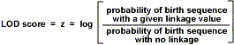
lod score = log₁₀ of the likelihood ratio
So a likelihood ratio of 10:1 equals of lod score of 1, a ratio of 100:1 equals a lod score of 2, a likelihood ratio of 1,000,000:1 equals of lod score of 6 and so forth.

Formulas that can be used:
Z (θ ) = log [(1 -θ )^{n-r} θ ^{r}/ (1/2)^{n}], where n= total number of births and r= number of recombinant types
Alternate formula:
Z (θ ) = (n - r) log [2 (1 - θ )] + r log (2 θ )
One calculates LOD scores based on various recombination frequencies, so
Z θ ₁ = LOD score based on θ ₁
Z θ ₂ = LOD score based on another recombination frequency θ ₂
Z θ ₃ = LOD score based on θ ₃, etc.
If more than one mating is available, LOD scores for each tested recombination frequency (θ ) may be calculated for each mating. The LODs determined for each mating may then be added together to obtain a composite LOD score, the θ value under consideration.

One Way of Calculating LOD Scores (the most intuitive to me)
1. Select a beginning recombination frequency (theta, θ ).
Since there is one recombinant out of 8 total in this progeny population, we will first test a θ value = 1/8 = 0.125 (to our knowledge at this point, the most likely value)
2. Determine the probability of either a parental or recombinant birth.
The first grandchild has a nonrecombinant (parental) genotype. The probablity of this event is (1 - 0.125) (1 - the chosen θ value). Because there are two potential parental types (AONpnp and BOnpnp), this value is divided by two to give a value of 0.4375. In this pedigree there is a total of seven parental types. There is also one recombinant type. The probability of this event is 0.125, which is divided by two because two potential recombinant types exist (AOnpnp and BONpnp).
recombinant probability = θ/2 = 0.125/2 = 0.0625
parental probability = 1 - θ/2 = (1 - 0.125)/2 = 0.4375
3. Determine the probability of the given birth series given the selected θ value.
The example has seven parental and one recombinant births.
probability = (0.4375)⁷(0.0625)¹ = (0.0031) (0.0625) = 0.0002
4. Determine the probability of a given birth series without linkage.
The probability for any birth is 0.25 because without linkage all four possible genotypes are equally probable.
probability = (0.25)⁸ = 0.0000153
5. Determine the LOD Score.
LOD Score = log (0.0002/0.0000153) = 1.1163
6. Repeat the sequence of calculations with other theta values.
7. Determine which theta value gives the highest LOD score. That is your best linkage estimate.
Recombination Frequency (RF) | LOD Score
0.050 | 0.951
0.100 | 1.088
0.125 | 1.1163
0.150 | 1.090
0.200 | 1.031
0.250 | 0.932
Relative likelihoods can be calculated under the assumption that the two genes are tightly linked with no recombination occurring between them at all, i.e. with the recombination fraction θ = 0, or for any other value of θ that we care to choose. The value of θ for which Z reaches a maximum positive value is the best estimate of the distance between the two loci. The value of Z_{max} is a measure of our confidence in the result.
In this example, Z_{max} is 1.1163 at a θ value of 0.125. This would not be considered a significant LOD value. Why wasn't a significant value obtained if the loci are indeed linked? Because the sample size was too small. Geneticists conventionally assume that a LOD value of 3.0 or higher indicates linkage. However, to obtain a value this high, even if the linkage hypothesis is correct, larger sample sizes are needed. Linkage estimates can be reported with LOD score < 3.0, but are generally qualified as the best estimate given the pedigree information available.
In some instances, the LOD score will be a negative value; in the example below, the LOD score Z has sunk to minus infinity at θ = 0. This will be the case if there has been at least one recombination event between the genes, they cannot then be zero distance apart. It is often helpful to display the data graphically. In the graph below, the maximum value of Z occurs at a recombination fraction of 0.1 and it is greater than 3. Therefore we can feel confident that the two genes are indeed linked and our best estimate for the genetic distance between them is θ = 0.1 (equivalent to 10cM). Compare this with the blue curve plotted for two unlinked genes. In this case Z is always negative and the best estimate of θ is 0.5 i.e. unlinked.
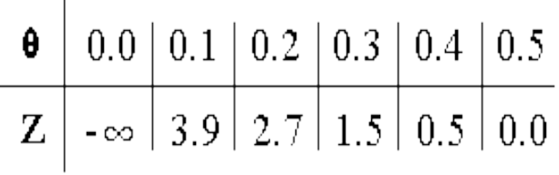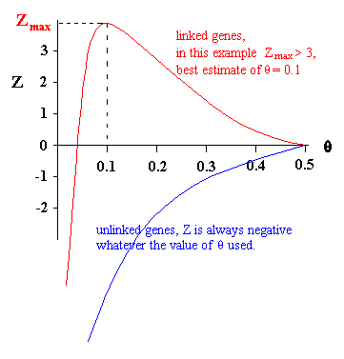

In a single small family, LOD scores are often in the range of 0 < LOD < 1 or 1.5. However, LOD scores are additive. If there are different families available to consider, LOD scores can be calculated for each family and added:

q | 0.0 | 0.001 | 0.01 | 0.1 | 0.2 | 0.3 | 0.4 | 0.5
Family 1
Family 2
Family 3
Total
The value between 0 < θ < 0.5 resulting in the highest LOD score is called the maximum likelihood estimate (MLE) (θ ) of the recombination fraction. If one or more LOD scores are reasonably large, the largest would give a clue as to the correct recombination frequency. Linkage is considered likely if a LOD score is greater than 3.0 (some researchers say 4.0).
(It is often stated that if a LOD value is > 3, the odds are more than 1,000 times greater that the loci are linked than that they were not. Given 2 randomly chosen loci in the human genome, they are likely to be on different chromosome arms. Roughly, the odds are 50:1 against linkage. Even though the data may be 1000 times more likely to have arisen under linkage than under nonlinkage, the fact that non-linkages are 50 times more common than linkages implies that a LOD score of 3 corresponds to only about a 20:1 odds in favor of linkage. That is, a LOD score of 3 will prove spurious one time in 20. A LOD score of 4 will be spurious one time in 200.
The parameters that are specified in performing a parametric analysis are as follows:
- Frequency of the mutant allele at the trait locus in the population
- Frequency of each allele of the marker locus in the population
- Genotype-specific penetrances at the trait locus
e.g., the likelihood of having the disease phenotype when carrying 0, 1 or 2 copies of the mutant allele. This permits specification of the trait as dominant or recessive, and permits allowance for phenocopies (individuals who have the disease despite not inheriting the disease gene) and incomplete penetrance (individuals who have inherited the disease gene but who do not have the disease).
- Recombination fraction between trait and marker loci

Let's look at a second example, using the same 2 traits:
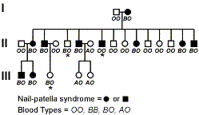
Again, nail-patella syndrome appears to be dominant because affected individuals all had at least one parent with the disease. From an examination of the progeny in generation II, it is possible to determine the complete genotypes of the parents in generation I. The non-affected parent must be homozygous recessive for the disease. The affected parent in generation I must be heterozygous Npnp because about half of his offspring are homozygous recessive.
The blood type data is clear. Again the non-affected male is homozygous recessive whereas the affected female is heterozygous.
Again, the parental mating in generation I is a test cross situation; the male is homozygous recessive at both genes, and the female is heterozygous at both genes. However, even though we are considering the same two genes, nail-patella and blood type, as in the previous pedigree, this time the dominant Np allele appears to be coupled with the B blood type allele instead of the A allele. It is frequently observed that linkages between alleles of two genes are are not constant throughout a species. Why? Because at some point (fairly recently in evolutionary time in this case) the Np allele recombined and became linked to a different blood type allele. In other lineages, the Np allele could be linked to the O blood type allele. This has to be determined for each family or population under study.
The next step is to determine whether these 2 genes assort independently or if they appear to move as a block into the gametes.
By looking at the pedigree, we can see that in almost all cases, individuals with nail-patella syndrome also posses the B blood type allele. This strongly suggests that the nail-patella and blood type genes are linked, and that the dominant allele responsible for the disease is in coupling with the B allele at the blood type locus.
However, not all of the offspring show this linkage. Which of the offspring are the recombinants? In generation II, the second male offspring of the marriage (II-5) does not have the disease but does inherit the B allele. The fourth male offspring (II-8) has the disease, but does not have a B allele. In generation III, offspring III-3 of the marriage of the first male in generation II has the B allele, but is not affected by the disease.
This information can be used to estimate the linkage distance between the two genes. Something that we have not considered yet is that multigenerational information can be used to calculate LOD scores. It is only necessary that the matings used in the calculation be informative. This means in this case that the 13 children produced in generation II (not their mates!) and the 5 progeny in generation III can be used in the calculations. Therefore there is a total of 18 offspring that are informative. Of these we determined that 3 were recombinant. A simple way to calculate recombination is to take the simple ratio [100*(3/18)].

Recombination Frequency (RF) | LOD Score Family 1 | LOD Score Family 2 | Total Score
0.050 | 0.951
0.100 | 1.088
0.125 | 1.1163 | 1.8394 | 2.955
0.150 | 1.090
0.200 | 1.031
0.250 | 0.932
A lod score of 3.0 or greater, representing an odds ratio of 1000:1 in favor of linkage, is commonly used as the threshold for significant evidence in favor of linkage; this corresponds to a nominal p-value of about 0.05. Conversely, a lod score of -2.0 or less, odds of 100:1 against linkage, constitutes exclusion of linkage between the trait and marker.

Linkage with Recessive Traits
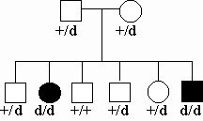
Consider a kindred segregating an autosomal recessive trait with two affected and 4 unaffected offspring of unaffected, unrelated parents; at the underlying disease locus, we anticipate that the two affected siblings have both inherited the same two mutant alleles, but that none of their unaffected siblings have inherited both of these mutant alleles:
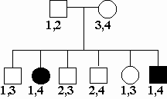
Specifying a model of high penetrance, rare phenocopies and a marker completely linked to the trait locus (recombination fraction of zero), one would expect the genotypes at the marker locus of the two affected siblings to be identical, and that none of the unaffected members would have the same marker genotype.
In this case we can set phase simply, specific marker alleles from each parent must be linked to disease alleles. Thus, if the disease and marker locus are linked, allele 1 and allele 4 must be linked to the disease alleles and alleles 2 and 3 must be linked to wild-type alleles. In this case, then, what is the likelihood that any additional affected sibling will by chance have the identical marker genotype? The likelihood that both alleles will be identical by chance is 1/4. Conversely, the likelihood that an unaffected sibling will by chance have a genotype different from the affected subject is 3/4 (1-the likelihood of being identical). So for recessive traits showing precise co-segregation of trait and marker loci, one can see that each additional affected subject will add a factor of 1/4 to the denominator of the likelihood ratio and each additional unaffected subject will add a factor of 3/4 to the denominator. So for this kindred, the likelihood ratio can be calculated as:
likelihood of observed results assuming linkage = _________1_________
likelihood of observed results occurring by chance (1/4)(3/4)(3/4)(3/4)(3/4)(1/4)
= likelihood ratio 50.5:1 in favor of linkage = lod score 1.7033.

MULTIPOINT ANALYSIS
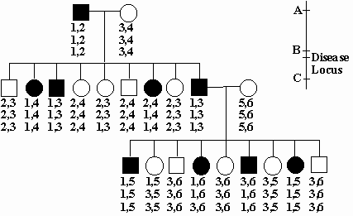

Up to now we have only considered inheritance at a single marker locus. However, by concurrently considering the inheritance of multiple loci in an interval one can maximize the informativeness of inheritance in the interval and can also define the boundaries within which the disease gene lies. In addition, we can consider the possibility that the disease gene lies anywhere on the genetic map, calculating the likelihoods for locations ranging from unlinked (recombination fraction 50%) to linked at a recombination fraction of zero and all recombination fractions in between. While such computations are impractical to perform by hand, they can easily be performed on high-speed computers. Returning to our dominant kindred, consider the inheritance of 3 markers loci in the vicinity of the disease gene. Locus A lies 17 cM proximal to the disease locus, locus B shows zero recombination with the disease locus and locus C is 11 cM distal to the disease locus. The alleles of different marker loci that are linked to one another on the same chromosome is referred to as a haplotype, and one can infer that the haplotype of allele 1 at locus A, allele 1 at locus B, and allele 1 at locus C is present in the father of the first generation and segregates with the disease in most individuals. However, a few recombination events are observed. For example, one affected female has inherited a chromosome showing recombination in the interval between locus A and B, receiving the linked alleles of loci B and C (alleles 1) but the unlinked allele of locus A (allele 2). Since she also inherited the disease gene, the disease gene must lie distal to, or below, locus A. Similarly, another affected subject in generation 3 has inherited linked alleles of locus A and B (alleles 1), but the unlinked allele at locus C (allele 3), indicating that the disease locus lies proximal to locus C. Taken together, these data support a position of the disease gene in the interval between loci A and C. We can calculate the lod score for linkage at all points across this chromosome interval and graph the lod scores.
We would see that the lod score peak lies at zero recombination with locus B, and is diminished as one moves proximal or distal to this location. The points at which the lod score drops from its peak by one unit (i.e., from 5.1 to 4.1) to either side approximates the 95% confidence interval for the location of the disease gene. This tells us where to look to find the disease gene.
It should be apparent from the above examples that doing linkage analysis by hand is extremely laborious. And, in linkage mapping, 2 point analysis is just a starting point. In reality, as linkage maps become more highly populated, one must do simultaneous analysis of many loci.
Between n gene loci: n (n-1)/ 2 recombination fractions
  - n loci can be ordered in n!/2 way (i.e. n (n-1) (n-2).../2)
Therefore, as discussed earlier, linkage analysis is now done with computers and mapping software programs.

Limitations to Linkage
What are the factors that determine 1) whether one can find significant evidence of linkage for a trait and 2) how precisely can one localize the disease gene on the genetic map?
One limiting factor is how many informative meiotic events one has available for analysis. One can see that for a dominant trait of high penetrance and a completely linked and fully informative genetic marker, having 10 phase-known meiotic events in a single kindred would be sufficient to potentially provide a significant lod score of 3.0 [likelihood ratio = 1/(1/2)¹⁰ = 1024:1] however, the ability to localize the gene would be very limited, with the interval containing the disease gene narrowed to a large segment of 10 - 20 cM, equivalent to about 10 - 20 million base pairs. Finding the disease gene in this interval may prove extremely difficult!!! Narrowing the interval by linkage is dependent upon identification of critical recombination events, and the likelihood of finding these is proportional to the number of informative meioses studied. Thus with 100 informative meioses one expects to refine the location of the disease locus, on average to a 1-2 cM interval. While this still constitutes a large interval, it is more readily handled.
However, one will rarely encounter a single family with anywhere near that many informative meioses. Fortunately, for a disease that is uniformly caused by mutation in the same gene, the lod scores across different families can be added to one another, and critical recombination events in any such family can be used to refine the location of the disease locus. For some diseases, however, one may encounter genetic locus heterogeneity, in which mutations in different genes cause the disease in different families. This can complicate the analysis, requiring that refinement of the location of the disease gene rely solely upon families with high likelihoods of linkage to a particular disease locus.

A second practical limitation to analysis of linkage is that genetic markers are commonly not completely informative in families. This commonly occurs because some individuals in the kindred may not be available for study or are deceased, or because some individuals may be homozygous for alleles of a marker, or because both parents may have the same copy of a marker allele, in which case it might be impossible to determine which parent contributed the allele. For example, in the kindred below, the affected parent is deceased and his genotype cannot be directly determined and also cannot be unambiguously inferred from the genotypes of the children.
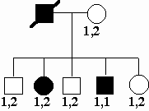

Similarly, in the next kindred, the affected parent is homozygous at the marker
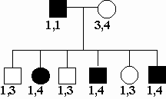
locus, and consequently one cannot determine whether or not alleles of the marker are co-segregating with the trait. As the likelihood of co-segregation at zero recombination or independent assortment are equally likely, the lod score for such a family is 0.
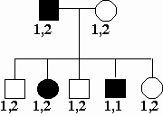
Finally, for the kindred above, both parents have genotype 1,2 at the marker locus, and consequently it is ambiguous as to which allele is transmitted from the affected parent to all but one of the offspring. Again, the lod score for such a family is zero.
Fortunately, with the dense genetic maps presently available it is almost always possible to genotype additional markers in an interval to increase the informativeness of inheritance in a chromosome segment.

Nonparmetric Methods of Mapping
Finally, we won't have time to discuss this in any depth, but there are methods of determining linkage by using nonparametric methods. These methods compare putative linkages over populations, rather than only in individual families.

